$
*+,- ./ 0 1

!" # $%& '" (" )$

2345678987:;<=>?6@;A8?8B;:>96B:C8>D6;8C8E;@6F8B:?8>3;
G34587@E;767HE8C;?E8CE;?EHDI8?;A8B:;?E8CE;?E@6BDI8?;C6BC6>CE3;
;
;
J+,/ 0KL MNML0
OPQRSTUOVQ$8C8E;WQXURSYUO$YSZUT$76BE@8<8>;?E8CE;D8B8;E>CE<;76>EBE><8>;?E8CE;DI8?;[8>\; I6H:9;E7E7;76>]8A:;?E8CE;DI8?;[8>\;I6H:9;?@6?:^:<3;_>96B:C8>D6;8A8I89;?8I89;?8CE;D:B:;EC878;?E8CE; H898?8;@B=\B87;[8>\;H6B=B:6>C8?:;@8A8;=H]6<3;_>C:;A8B:;@6F8B:?8>;8A8I89;?:^8C;B6E?8HI6;A8B:;<=>?6@;
=H]6DC;=B:6>C6A3;`6C:8@;YabVcUY$8<8>;d76F8B:?:e;?:^8C;A8B:;YaWQRVcUYY$?6I878;H6B?:^8C;@B=C6DC6A;
8C8E@E>;@EHI:D3;

f8I87;:>96B:C8>D6;C6BA8@8C;AE8;:?C:I89;[8>\;?6B:>\;A:\E>8<8>3;g6I8?;[8>\;76>EBE><8>; A:?6HEC;<6I8?;A8?8B;hbUYQ$VcUYiYaWQR$VcUYYjk;?6A8>\<8>;<6I8?;[8>\;A:CEBE><8>;A:?6HEC;<6I8?;CEBE>8>; hlQRSmQl$VcUYiYab$VcUYiVPScl$VcUYj;3;f:;A8I87;n8o8;E>CE<;76>A6<I8B8?:<8>;?E8CE;DI8?;?6H8\8:;
?EHDI8?;A:I8<E<8>;A6>\8>;D8B8;76>87H89<8>;<8C8;<E>D:;QpTQOlY$?6C6I89;A6<I8B8?:;>878;DI8?k;
<67EA:8>;A:<EC:;A6>\8>;>878;@8B6>C;DI8??q>[83;g8C8;<E>D:;6rC6>A?;C6B?6HEC;767H6B:C89E;<=7@:I6B;
n8o8;H89F8;<:C8;:>\:>;76I8<E<8>;@6BIE8?8>;DI8?3;s6B:<EC;8A8I89;D=>C=9;A6<I8B8?:;:>96B:C8>D63;
;

t=>C=9;A:8C8?;767H6B:C89E<8>;<=7@:I6B;n8o8;H89F8;<:C8;:>\:>;76>\q6rC6>A;DI8??;u;<6;DI8?;s3;
f6>\8>;<8C8;I8:>k;DI8?;s;8A8I89;?EHDI8?;hDI8?;CEBE>8>j;A8B:;DI8?;uk;?6A8>\<8>;DI8?;u;8A8I89;
@8B6>C;DI8?;A8B:;DI8?;s3;

g8B8<C6B:?C:<;@8A8;?E@6B;DI8?;8<8>;A:7:I:<:;]E\8;=I69;?EHDI8?>[83;v6BA8@8C;w;H6>CE<;
@6F8B:?8>x;?:>\I6;:>96B:C8>D6k;7EIC:I6o6I;:>96B:C8>D6k;A8>;7EIC:@I6;:>96B:C8>D63;y87E>;[8>\;8<8>; A:H898?;@8A8;]=H?966C;:>:;8A8I89;?:>\I6;:>96B:C8>D6;A8>;7EIC:I6o6I;:>96B:C8>D63;

234`:>\I6;_>96B:C8>D6;
`:>\I6;:>96B:C8>D6;8A8I89;`E8CE;DI8?;[8>\;98>[8;767@E>[8:;?8CE;@8B6>C;DI8??3;t=>C=9x;
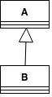
z87H8B;23;t=>C=9;`:>\I6;_>96B:C8>D6;

! ! "

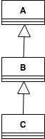
! !

#
$

#

% # #
#
& # ! ' ( )
* ! ! ' % )+ ! !
"

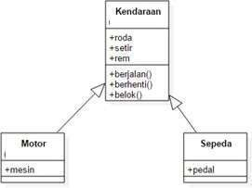

, ! !

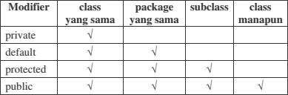

!" #$%&'()*+*,-'./$-0
1 2 2
!" #$%&'()*+*3&-456780
1 2 2
!" #$%&'780
1 2 2
9
!" #$%&'7%*'*+&-&':;0%*'*+&-&'<;6#-80
1 2

=

>?@ABCDEFGGHIJIKLMNLOPQRI
G?@SGTGAGHIABCDEFGGHI
U "V 2 W X

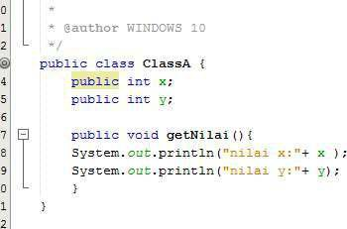

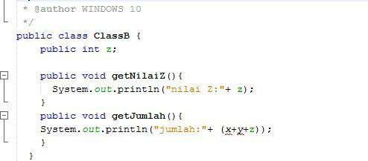

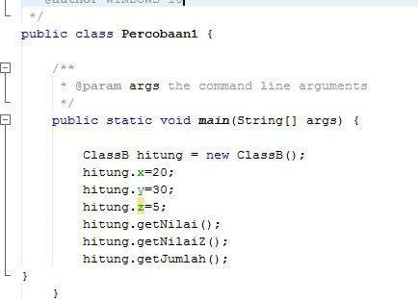

! "

#$%&'()*+,**+-
" !

"

! " # $ % & # $" ' %( % % ) * + , -

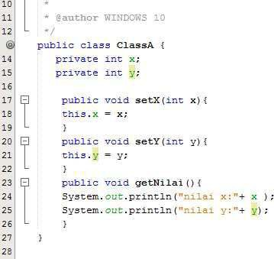
. ! " % /& !" ' %( % % ) * , -

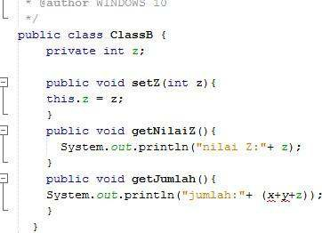

0 " 1 $"2! %. , - % / ) %, %/ % #$2($ ) '3 4
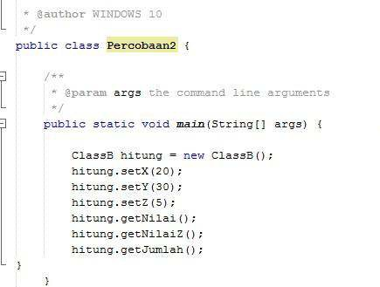

! "
# $ % & ' & (
& &

' & & % & #

) *+ ","-./0123"
4 " *+ "
# 5 ( & ( % 6 % 5 7

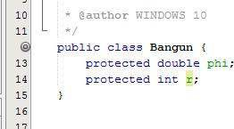
' 5 ( & ( % 6 &% 8 & 7
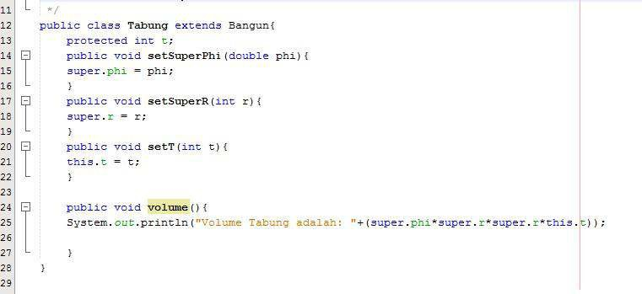

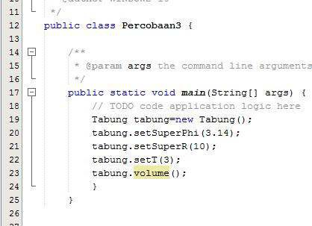

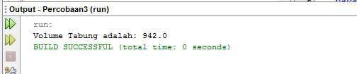

!"#$%&$$%'
( ) * + ,

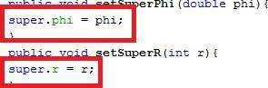

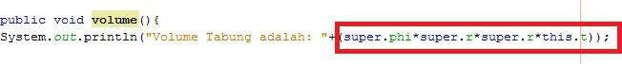

!"#$%&&'()(*+,-./(0123+/,031/4(
& 5&6& &'( !"#$%&&'(

7 8 9 : ; < = 9 8 ; < = 9 9 ; < =
>
9 : ; <
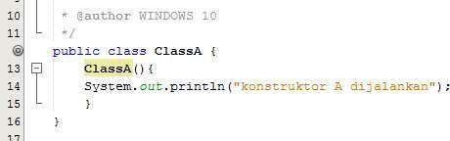
9 8 ; <
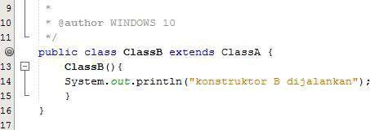
9 9 ; <

 

    



   


